A PROJECT REPORT

On

Consumer perception about life insurance policies

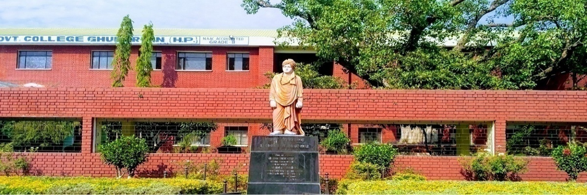

In partial fulfilment of the requirement for the award of the degree

Of

BACHELOR OF BUSINESS ADMINISTRATION

SWAMI VIVEKANANDA GOVT. COLLEGE GHUMARWIN

SESSION 2021-2022

SUBMITTED TO: SUBMITTED BY: Mr. Naresh kumar Gaurav Assistant Professor UNIV ROLL.5190350009

**DECLARATION**

I **GAURAV** hereby declare that the project report was submitted by me under the supervision and guidance of ASST. PROF. Naresh kumar, project guide college of **SWAMI VIVEKANAND GOVERMENT COLLEGE, GHUMARWIN** in partial fulfilment of BBA 6th semester. I further declare that I am solely responsible for omission and commission of errors if any.

Signature

GAURAV

University Roll no. 5190350009

DATE -

**ACKNOWLEDGMENT**

“Acknowledgement is an art, one can write glib stanzas without meaning a word, on other hand one can make a simple expression of gratitude” I take the opportunity to express my gratitude to all of them who in some or other way helped me to accomplish this challenging training no amount of written expression is sufficient to show my deepest sense of reference to Principal Prof. Ramkrishan , Co-ordinator Assistant Professor Rajender Kumar and Assistant professor Naresh kumar (Project Guide). I also express deepest gratitude to my family for their blessing and good wishes.

I also acknowledge with a deep sense of reverence, my gratitude towards my parents and my friends who directly or indirectly help me.

Gaurav

**CERTIFICATE**

This is to certify that the report entitled “Consumer perception about life insurance policies” for the award of the degree of Bachelor Of Business Administration (BBA) from SWAMI VIVEKANAND GOVT. COLLEGE, GHUMARWIN (HP), Is a record to project report carried out by **Gaurav BBA 6TH Sem. UNIV. ROLL No.5190350009** under my supervision and guidance, no part of this report has been submitted to any other Degree /Diploma and this report may be taken for evaluation.

**Sign of Student**

**Sign of Guide**

**Sign of Coordinator**

Date-

Place- Ghumarwin

**Table of content**

|  |  |  |
| --- | --- | --- |
| **Sr. No** | **Title of the chapter** | **Page Number** |
| **1.** | **Corporation profile and introduction**  1.1 introduction to the topic  1.2 Background to the study |  |
| **2.** | **Research methodology**  2.1 Statement to the problem  2.2 Scope of the study  2.3 Need for the study  2.4 Objective to the study  2.5 Review of literature  2.6 Research design  2.7 Sample design |  |
| **3.** | **Data analysis &interpretation** |  |
| **4.** | **Finding, suggestions and conclusion** |  |
| **5.** | **Questionnaire** |  |

CHAPTER - 1

INTRODUCTION AND CORPORATION PROFILE

PROFILE OF THE INDUSTRY:

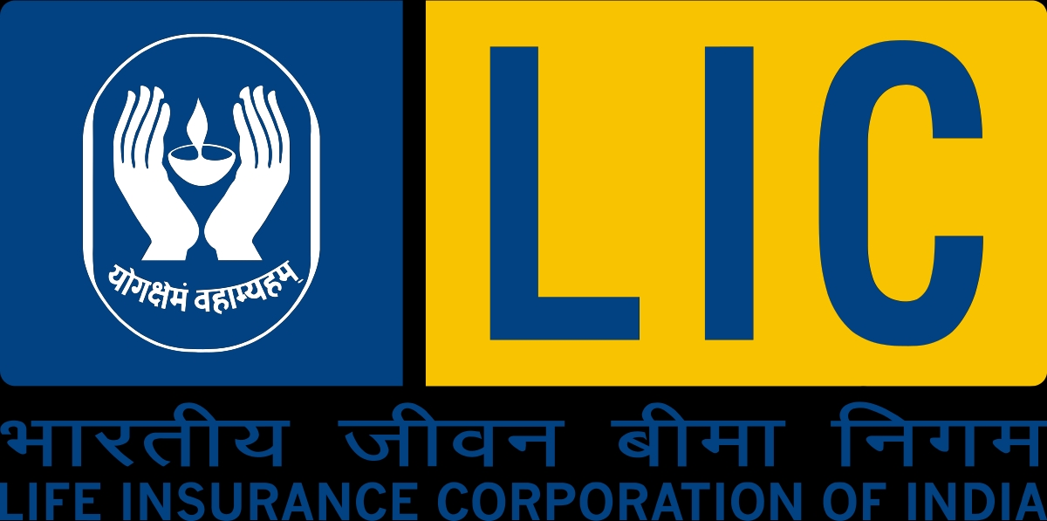

History and Development of Life Insurance

1. Life Insurance, in its present form, came to India from the United Kingdom with establishment of a British firm, Oriental Life Insurance Company in Calcutta in 1818, followed by Bombay Life Assurance Company in 1823, the Madras Equitable Life Insurance society in 1829 and Oriental Government security Assurance Company in 1874. Prior to 1871, Indian Lives were treated as sub-standard and charged an extra premium of 15% to 20%. Bombay Mutual Life Assurance Society, A Indian insurer which came into existence in 1871 was the first to cover Indian lives at normal rates.

2. The Indian life Assurance Companies Act, 1912 was the first statutory measure to regulate life insurance business. Later, in 1928, the Indian Insurance Companies Act was enacted, to enable the government to collect statistical information about both life and non-life insurance business transacted in India by Indian and foreign insurers, including the provident insurance societies.

Comprehensive arrangement was, however, brought into effect with the enactment of the Insurance Act, 1938. Efforts in this direction continued progressively and the act was amended in 1950, making far-reaching changes, such as requirement of equity capital for companies carrying on life insurance business, ceiling on share holdings in such companies, submission of periodical return relating to investments and such other information to the controller of insurance as he many call for, appointment of administrator for mismanaged companies, ceiling on expenses of management and agency commission, incorporation of the Insurance association of India and formation of councils and committees there Of.

3. By 1956, 154 Indian insurers, 16 non-Indian insurers and 15 provident societies were carrying online insurance business in India. On 19th January 1956, the management of the entire life insurance business of 229

Indian insurers and provident insurance societies and the Indian life insurance business of 16 non Indian Life insurance companies then operating in India, was taken over by the central Government and then nationalized on 1st September 1956 when the Life Insurance Corporation came into existence.

Reforms and Implications

The liberalization of the Indian insurance sector has been the subject of much heated debate for some years. The sector is finally set to open up to private competition. The Insurance Regulatory and Development Authority bill will clear was the for private entry into insurance as the government is keen to invite private sector participation into insurance. To address those concerns, the bill requires direct insurers to have a minimum paid-up capital of Rest. 1 billion, to invest policyholder’s funds only in India; and to restrict international companies to a minority equity holdings of 26 percent in any new company. Indian Promoters will also have to dilute their equity holding to 26 percent over a 10 year period. Over the past three year, around 30 companies have expressed interest in entering the sector and many foreign and Indian companies have arranged alliances. Whether the insurer is old or new, private or public, expanding the market will present challenges.

**1.1 INTRODUCTION TO THE STUDY**

Everyone is exposed to various risks. Future is very uncertain, but there is way to protect one’s family and make one’s children’s future safe. Life Insurance companies help us to ensure that our family’s future is not just secure but also prosperous.

This study titled “Study of Consumers Perception about Life Insurance Policies” enables the Life Insurance Companies to understand how consumer’s perception differs from person to person. How a consumer selects, organizes and interprets the service quality and the product quality of different Life Insurance Policies, offered by various Life Insurance Companies. The likely impact of opening up of India’s insurance sector is that private players may swamp the market. International insurers often derive a significant part of their business from multinational operations. Multinational insurers are indeed keenly interested as; perhaps their home markets are saturated while emerging countries have low insurance penetration and high growth rates. A small share of a large and growing market can be profitable and attractive.

1.2 BACKGROUND OF THE STUDY

“Life Insurance is a contract for payment of a sum of money to the person assured on the happening of the event insured against”. Usually the insurance contract provides for the payment of an amount on the date of maturity or at specified dates at periodic intervals or at unfortunate death if it occurs earlier. Obviously, there is a price to be paid for this benefit. Among other things the contracts also provides for the payment of premiums, by the assured.

Life Insurance is universally acknowledged as a tool to eliminate risk, substitute certainty for uncertainty and ensure timely aid for the family in the unfortunate event of the death of the breadwinner. In other words, it is the civilized world’s partial solution to the problems caused by death. Life insurance helps in two ways dealing with premature death, which leaves dependent families to fend for themselves and old age without visible means of support.

Benefits of Life Insurance Policies

1) Superior to any other savings plan:

Unlike any other savings plan, a life insurance policy affords full protection against risk of death. In the event of death of a policy holder, the insurance company makes available the full sum assured to policy holder’s near and dear ones. In comparison, any other savings plan would amount to only the total savings plan accumulated till date. If the death occurs prematurely, such savings can be much less than the sum assured which means that the potential financial loss to the family is sizable.

2) Encourages and Forces Thrifts:

A saving deposit can easily be withdrawn. The payment of life insurance premium, however, is considered sacrosanct and is viewed with the same seriousness as the payment of interest on a mortgage. Thus, a life insurance policy in effect brings about compulsory savings.

3) Easy settlement and protection against creditors:

A life insurance policy is the only financial instrument the proceeds of which can be protected against the claims of a creditor of the assured by effecting a valid assignment of the policy.

4) Administering the Legacy for Beneficiaries:

Speculative or unwise expenses can quickly cause the proceeds to be squandered.

Several policies have foreseen this possibility and provide for payment over a period of years or in a combination of installments and lump sum amounts.

5) Ready Marketability and suitability for quick borrowing:

A life insurance policy can, after a certain time period (generally three years) be surrendered for a cash value the policy is also acceptable as a security for a commercial loan, for example, a student loan.

CHAPTER 2

RESEARCH METHOLOGY

2.1 STATEMENT OF THE PROBLEM

This Study will help us to understand the consumer’s perception about life insurance policies. This study will help the companies to understand, how a consumer selects, organizes and interprets the Quality of service and product offered by life insurance companies.

2.2 SCOPE OF THE STUDY

This study is limited to the consumers within the limit of Bangalore city.

The study will be able to reveal the preferences, needs, perception of the customers regarding the life insurance products, It also help the insurance companies to know whether the existing products are really satisfying the customer’s needs .

2.3 NEED FOR THE STUDY

1) The deeper the company’ s understanding of consumer’s needs and perception, the earlier the product is introduced ahead of competition, the greater the expected contribution margin. Hence the study is very important.

2) Consumer markets and consumer buying behaviour can be understood before sound product and marketing plans are developed

3) This study will help companies to customize the service and product, according to the consumer’s need.

4) This study will also help the companies to understand the experience and expectations of the existing customers.

5) Apart from creating, manufacturing and distribution capabilities for life insurance products, an in depth study of the consumers, their preferences and demand for their product is very necessary for setting up an efficient marketing network.

2.4 OBJECTIVE OF THE STUDY

1. Ascertain the profile and characteristics of potential buyers.

2. To gain a thorough understanding of the attributes that prospective buyers ascribe to life insurance policies.

3. To have an insight into the attitudes and behaviours of customers.

4. To find out the differences among perceived service and expected service.

5. To produce an executive service report to upgrade service characteristics of life insurance companies.

6. To understand consumer’s preferences.

7. To access the degree of satisfaction of the consumers with their current brand of Insurance products.

2.5 REVIEW OF LITERATURE:

To carry the research work the researcher has gone through a few reports,

books, journals and websites. The details regarding Life Insurance Industry, history, origin and growth of the industry is also taken from some books, magazines etc.

The sources of this information is as follows:

Catalogues and Broachers from various Life insurance companies

Articles from magazines and news paper Information from various websites.

2.6 RESEARCH DESIGN:

A research design is a basic plan which guides the researcher in the collection and analysis of data required for practicing the research. Infant the research design is the conceptual structure which the research is conducted. It constitutes the ‘Blue Print’ for the collection, measurement and analysis of the data.

The study is carried out to understand the Consumer Perception about life insurance policies in Ghumarwin City .For this study the researcher used exploratory research design.

This research covers 50 consumers in Ghumarwin city, belonging to various age groups.

2.7 SAMPLE DESIGN:-

The process of drawing a sample from a large population is called sampling.

Population refers to the total of items about which information is defined. Well selected samples may reflect fairly and accurately the characteristics of the population.

2.7.1) Sampling Unit:

The sample unit of this survey was the customers having life insurance policies in Ghumarwin city, Bilaspur (HP)

2.7.2) Sample Size: 50

2.7.3) Sampling Technique Adopted: Convenient sampling

**2.7.4): Source of data**

After identifying and defining the research problem and determining specific information required to solve the problem the researcher will look for the type and sources of data which may yield the desired results, while deciding about the method of data collection to be used for the study, there are two types of data.

They are as follows

2.8.1) Primary Data:

Primary data are those which are collected for the first time. Primary data is collected by framing questionnaires. The questionnaire contained questions which are both open-ended and closed-ended. Open-ended questions are questions requiring answers in the responders own words. Closed-ended questions are those wherein the respondent has to merely check appropriate answer from a list of options available. Any doubts raised by the Respondents were clarified to get the perfect answers from the distributors. Open-ended questions yielded more insightful information, whereas closed- Ended questions were relatively simple to tabulate and analyze.

**2.8.2) Secondary Data:**

Secondary data means data that are already available i.e. they refer to the data which have been collected and analyzed by someone and can save both money and time of the researcher. Secondary data may be available in the form of company records, trade publications, libraries etc .Secondary data sources are as follows:

♦ Company Reports

♦ Daily Newspaper

♦ Standard Textbook

♦ Various Websites

2.9 FIELD WORK

An interview-schedule and well-structured questionnaire is administered to the target respondents to collect primary data (Copy of questionnaire is attached in the appendix).Open and close ended questions are used in the questionnaire. The order of the questions is in such a manner that they begin with simple questions and lead on the questions that needed more involvement from respondents. The secondary data are collected from periodicals, magazines, journals and internet.

2.10 OPERATIONAL DEFINITIONS OF THE STUDY

1. Marketing:

Marketing is a social and managerial process by which individuals and group obtain what they need and want through creating, offering and exchanging products of value with others.

2. Marketing Management:

Marketing Management is the process of planning and executing the conception, pricing, promotion and distribution of individual and organizational goals.

3. Marketing Research:

Marketing research is the systematic and objective search for, and analysis of information relevant to the identification and solution of any problems in the field of marketing.

4. Consumer Behaviour:

Consumer behaviour is the study of how individuals make decisions to spend their available resources [time, money, efforts] on consumption related items.

5. Consumer Research:

Consumer research is the methodology used to study consumer behaviour.

6. Market Segmentation:

Market segmentation is the process of dividing a market in the distinct subsets of consumer with common needs or characteristics and selecting one or more segments to target with distinct marketing mix.

7. Positioning:

Positioning is the act of designing the company’s offering and image so that they occupy a meaningful and distinct competitive position in the target consumer’s mind.

8. Perception:

Perception is the process by which an individual selects, organizes, and interprets information input to create meaningful picture of the world. For a marketer to influence a motivated buyer to buy their products rather than competitors they must be careful to take the perception process into account while designing their marketing campaigns. Perception therefore influence what product consumer buys.

9. Brand:

A brand is a name, term, sign, symbol, or design or a combination of them, used to identify the goods or services of one seller or group of seller and the different them from those of competitors.

10. Attitude:

An attitude is a person enduring favourable or unfavourable evaluation, emotional feeling, and action tendencies towards some object or idea

11. Values:

A value is a concept of the desirable an internalized standard of evaluation a person possession. These standards determine or guide an individual evaluation of the many objects encountered in everyday life.

12. Attributes:

Attributes are the strengths and weaknesses of a brand that create attitudes and are used by consumers to choose between brands that are relatively similar or functionally equivalent.

Type of life insurance policies

Whole life insurance

Whole life is a form of permanent insurance, with guaranteed rates and guaranteed cash values. It is the least flexible form of permanent insurance. Universal life insurance

Universal life is similar to whole life, except that you can change the death benefit (the money paid to the beneficiary when the insured person dies), the amount of premiums and how often you pay the premiums.

Variable life insurance

Variable life insurance is the riskiest form of permanent insurance, but it can also give you the best return for your money. Essentially, the life insurance company will invest your insurance premiums for you. If the investments do well, the death benefit and cash value of the policy go up. If they do poorly, they go down. It's a little like putting your savings into the stock market.

Group life insurance

Many companies allow their employees to buy group life insurance through the company. Usually, you can get very good rates for this insurance but you have to give the insurance up when you stop working there. For that reason, group insurance can be a good way to buy a little extra life insurance, but it does not make sense to make it your main policy.

There are a number of policies for specific insurance needs. Some of these include:

1. Family income life insurance.

This is a decreasing term policy that provides a stated income for a fixed period of time, if the insured person dies during the term of coverage. These payments continue until the end of a time period specified when the policy is purchased.

2. Family insurance.

A whole life policy that insures all the members of an immediate family husband, wife and children. Usually the coverage is sold in units per person, with the primary wage-earner insured for the greatest amount.

3. Senior life insurance.

Also known as graded death benefit plans, they provide for a graded amount to be paid to the beneficiary. For example, in each of the first three to five years after the insured dies, the death benefit slowly increases. After that period, the entire death benefit is paid to the beneficiary. This might be appropriate if the beneficiary is not able to handle a large amount of money soon after the death, but would be in a better position to handle it a few years later.

4. Juvenile insurance.

This is life insurance on a child. Coverage is paid for by an adult, usually the parents or guardians. Such policies are not considered traditional life insurance because the child is not producing an income that needs to be protected. However, by buying the policy when the child is young, the parents are able to lock in an extremely low premium rate and allow many more years of tax-deferred cash value buildup.

4. Credit life insurance.

This insurance is designed to pay off the balance of a loan if you die before you have repaid it. Credit life insurance is available for many kinds of loans including student loans, auto loans, farm equipment loans, furniture and other personal loans including credit cards. Credit life insurance can be purchased by an individual.

Usually it is sold by financial institutions making loans, like banks, to borrowers at the time they take out the loan. If a borrower dies, the proceeds of the policy repays the loan directly to the lender or creditor.

5. Mortgage insurance

This decreasing term coverage is designed to pay off the unpaid balance of a mortgage if you die before the mortgage is paid off. Premiums are generally level throughout the term of the policy. The policy is usually independent of the mortgage, meaning that the financial institution granting the mortgage is separate from the insurance company issuing the policy. The proceeds of the policy are paid to the beneficiaries of the policy, not the mortgage company. The beneficiary is not required to use the proceeds to pay off the mortgage

6. Annuity

An annuity is a form of insurance that enables you to save for your retirement. Basically, you give the insurance company money for a certain period of time, and then after you retire they will pay you a certain amount of money every year until you die. There are many different forms of annuities. Most people who buy annuities are 55 or older.

Objectives of LIC

• Spread Life Insurance much more widely and in particular to the rural areas and to the socially and economically backward classes with a view to reaching all insurable persons in the country and providing them adequate financial cover against death at a reasonable cost.

• Maximize mobilization of people's savings by making insurance-linked savings adequately attractive.

• Bear in mind, in the investment of funds, the primary obligation to its policyholders, whose money it holds in trust, without losing sight of the interest of the community as a whole; the funds to be deployed to the best advantage of the investors as well as the community as a whole, keeping in view national priorities and obligations of attractive return.

• Conduct business with utmost economy and with the full realization that the moneys belong to the policyholders.

• Act as trustees of the insured public in their individual and collective capacities.

• Meet the various life insurance needs of the community that would arise in the changing social and economic environment.

Various policies offered by life insurance corporation of India are

1) Whole Life Schemes

• Whole life with profit

• Limited payment whole life

• Single Premium whole life

• Convertible whole life plan

2) Endowment Schemes

• Endowment plan with profit

• Limited payment Endowment

• Jeevan Mitra (Double Cover)

• Jeevan Mitra (Triple cover)

• Bhavishya Jeevan

• Jeevan Anand

• New Jana Raksha

3) Term Assurance Plan

• Anmol Jeevan

• 2 Year Term Assurance

• Covertible Term

• New Bima Kiran

4) Plan for needs of Children

• Komal Jeevan

• Jeevan Sukanya

• Jeevan Kishore

• Jeevan Balya

• Jeevan Chaya

• Marriage/educational annuity

• Deffered Endowment

5. Periodic Money Back Plan

• Jeevan Samridhi

• Jeevan Rekha Plan

• Money Back Plan

• Jeevan Surabhi

6. Medical benefits linked insurance

• Asha Deep II

• Jeevan Asha II

7. For benefits to Handicapped

• Jeevan Aadhar

• Jeevan Vishwas

8. Plans to cover housing loans

• Mortagage redemption

9. Joint life plan • Jeevan sathi

CHAPTER-3

DATA ANALYSIS

&

INTERPRETATION

4.1 DATA ANALYSIS TOOLS USED:

In order to extract meaningful information from the data them the analysis can be conducted by using simple statistical tools like percentages, averages and measures of dispersion. Alternatively the collected data may be analysed collected, the data analysis is carried out. The data are first edited, coded and tabulated for analyzing by using diagrams, graphs, charts, pictures etc. Data analysis is the process of planning the data in an ordered form, combining them with the existing information and extracting from them

Interpretation is the process of drawing conclusions from the gathered data in the study.

In this research the researcher has analysed the data using percentages and graphs In this research the data analysis tools used are percentages and graphs. The various attributes were analysed separately and the importance to each was calculated on the basis of the percentage. The rank having the maximum percentage was taken to be preferred importance to the particular attribute. After looking at each attribute separately, all the attributes were considered together to develop a map on the most preferred rank for all the attributes.

Table 1

|  |  |  |  |
| --- | --- | --- | --- |
| SL.NO | AGE IN YEARS | NUMBER OF RESPONDENTS | NUMBER OF RESPONDENTS |
| 1. | 19-28 | 28 | 56% |
| 2. | 29-38 | 9 | 18% |
| 3. | 39-48 | 9 | 12% |
| 4. | 49-58 | 0 | 12% |
| 5. | 59-68 | 6 | 0% |
| 6. | 69-78 | 1 | 2% |
|  | Total | 50 | 100% |

SOURCE:-SURVEY DATA

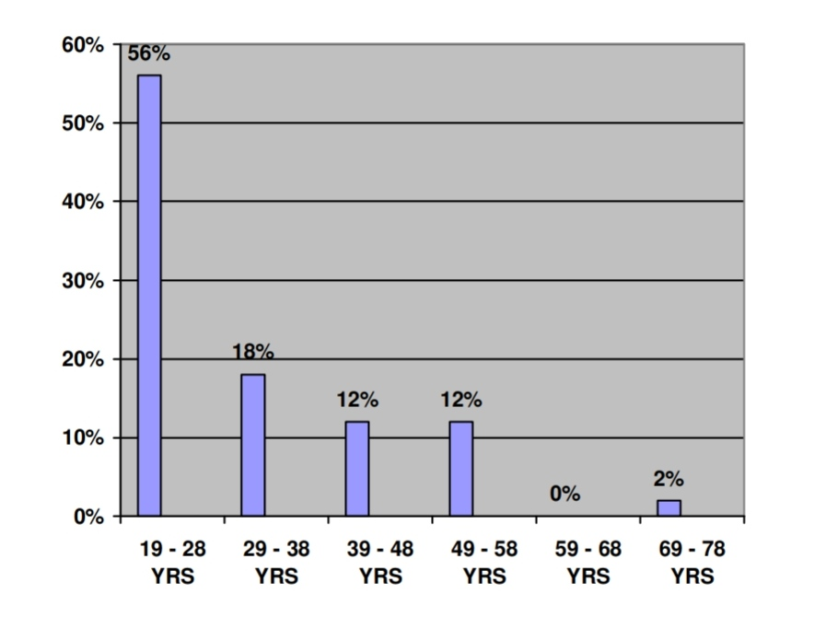

INTERPRETATION: The above table classified the respondents according to their age group.

The majority of the respondents belong to the age group 19 to 28 years with 56% and the second age group is 29 to 38 years with 18%, followed by 39 to 48 years and 49 to 58 years with 12% each

DIFFERENCIATION OF THE RESPONDENTS INTO MALE AND FEMALE:-

TABLE 2

|  |  |  |
| --- | --- | --- |
| TYPES OF RESPONDENTSFEMALE RESPONDENTS | NUMBER OF RESPONDENTS | NUMBER OF RESPONDENTS(%) |
| MALE RESPONDENTS | 37 | 74% |
| Female responds | 13 | 26% |
| Total | 50 | 100% |

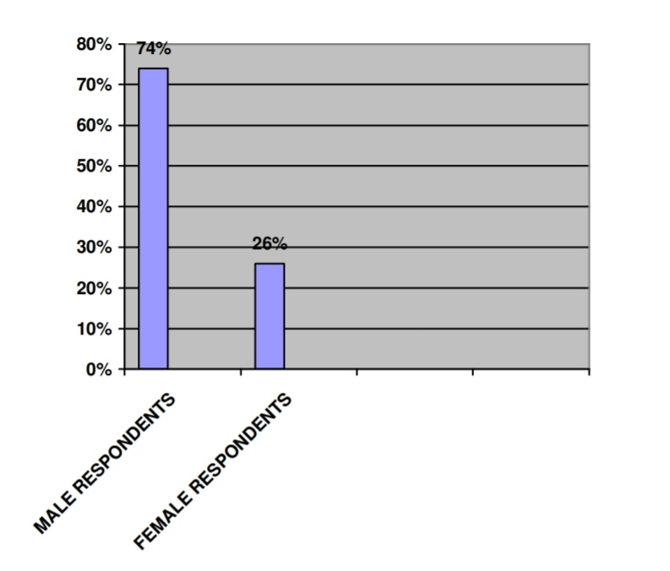

INTERPRETATION: This table helps us to understand that there are more number of male consumers with 74% market share

DIFFERENCIATION OF RESPONDENTS BASED ON THEIR OCCUPATION:-

TABLE 3

|  |  |  |  |
| --- | --- | --- | --- |
| SL.NO | OCCUPATION | Number of responds | Percentages of responds |
| 1 | Students | 2 | 4% |
| 2 | GOVERNMENT EMPLOYEES | 40 | 40% |
| 3 | PRIVATE EMPLOYEES | 24 | 48% |
| 4 | HOUSE WIVES | 2 | 4% |
| 5 | RETIRED PERSONS | 2 | 4% |
|  | Total | 50 | 100% |

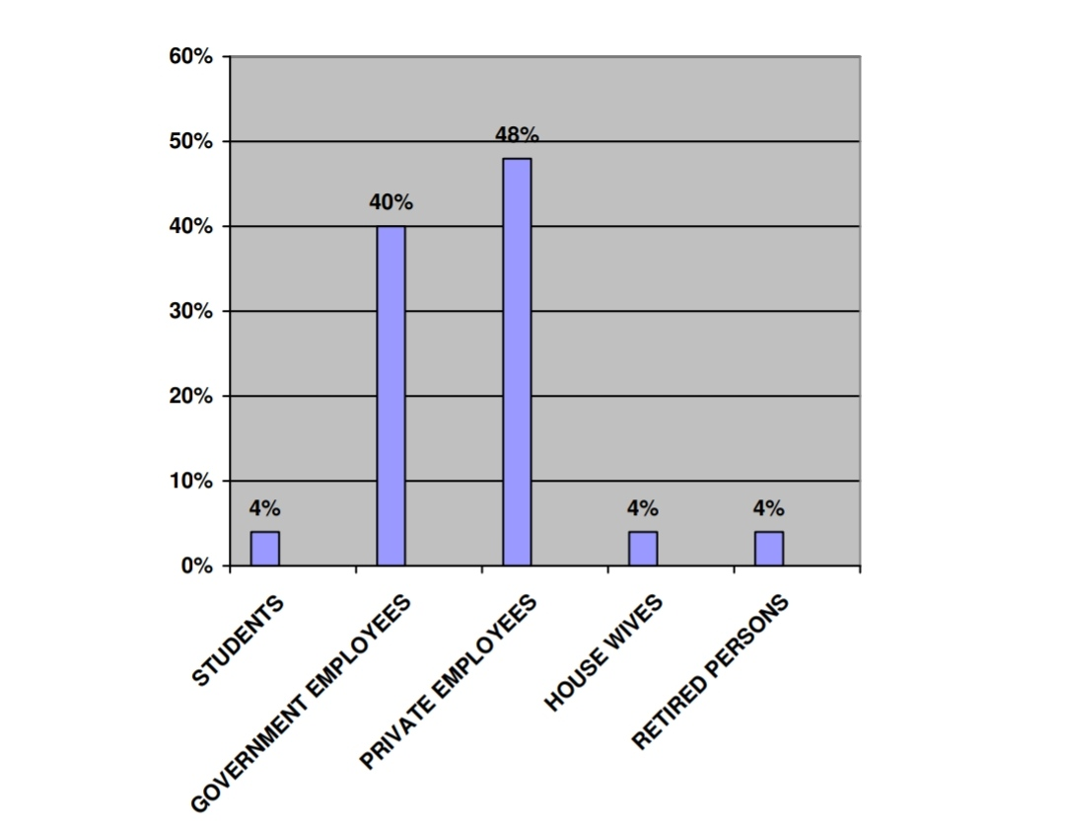

INFERENCE: It could be inferred that majority of consumers of life insurance policies are private employees with 48% and Government employees with 40%, followed by students, house wives and retired persons with 4 % each.

Factors which influenced to buy life insurance policy:-

TABLE 4

|  |  |  |  |
| --- | --- | --- | --- |
| SL.NO | FACTORS | SCORE | RANK |
| 1. | PERSONAL INTEREST | 28 | 1 |
| 2. | FAMILY | 16 | 2 |
| 3. | FRIENDS | 8 | 3 |
| 4. | AGENTS | 6 | 4 |
| 5. | OTHERS | 1 | 5 |
|  |  |  |  |

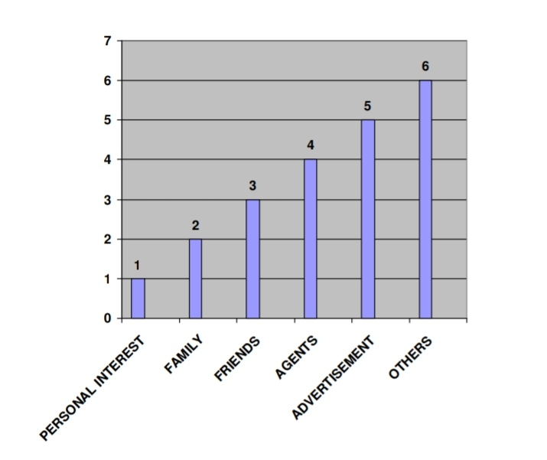

INFERENCE: This table is helpful in knowing which media is best suitable for promoting a life insurance product. It can be seen that personal interest influences a consumers to buy a life insurance product, followed by family, friends, agents and advertisements.

TABLE-5

Table showing income group of respondents:-

|  |  |  |  |
| --- | --- | --- | --- |
| SL.NO | INCOME  GROUP | NUMBER OF RESPONDENTS | PERCENTAGES OF RESPONDENTS |
| 1 | Less then  5000 | 9 | 18% |
| 2 | 5001-10000 | 17 | 34% |
| 3 | 10001-15000 | 14 | 28% |
| 4 | 15001-20000 | 7 | 14% |
| 5 | 20001-25000 | 2 | 4% |
| 6 | GREATER THAN30000 | 1 | 2% |
|  | TOTAL | 50 | 100% |

SOURCE:-SURVEY DATA

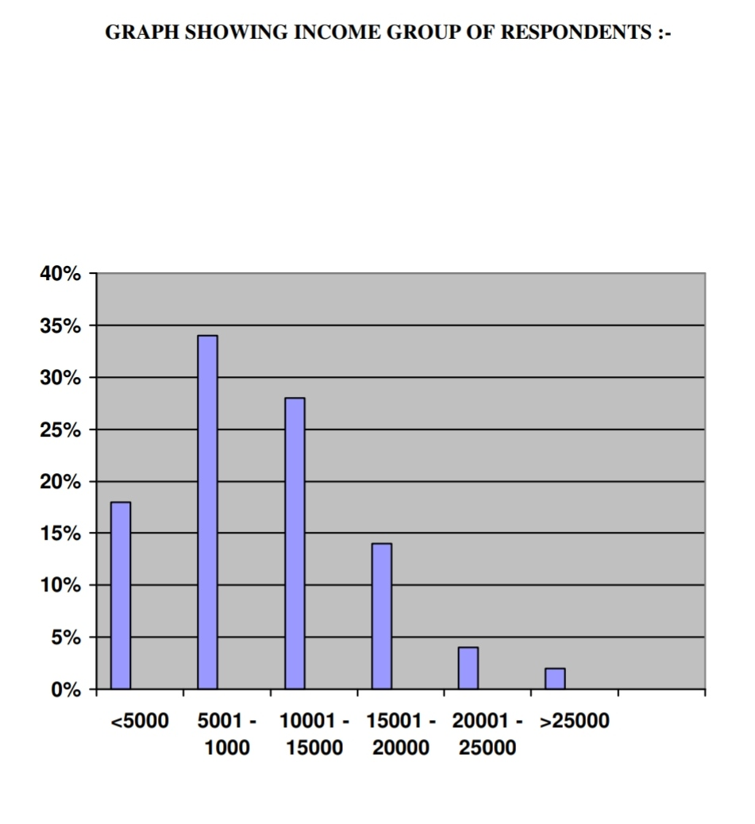

INFERENCE: The majority of dominant income group having life insurance policies belong to the income group of 5,001 to 10,000, which is middle class group. Followed by the income group of 10,001 to15,000

TABLE 6

DIFFERENCIATION OF RESPONDENTS ACCORDING TO THE ASSETS

|  |  |  |  |
| --- | --- | --- | --- |
| SL.NO. | ASSETS | NUMBER OF RESPONDENTS | PERCENTAGES  OF RESPONDENTS |
| 1 | HOUSE | 19 | 38 |
| 2 | TWO  WHEELER | 26 | 52 |
| 3 | CAR | 5 | 10 |
|  | TOTAL | 50 | 100 |

SOURCE:-SURVEY DATA

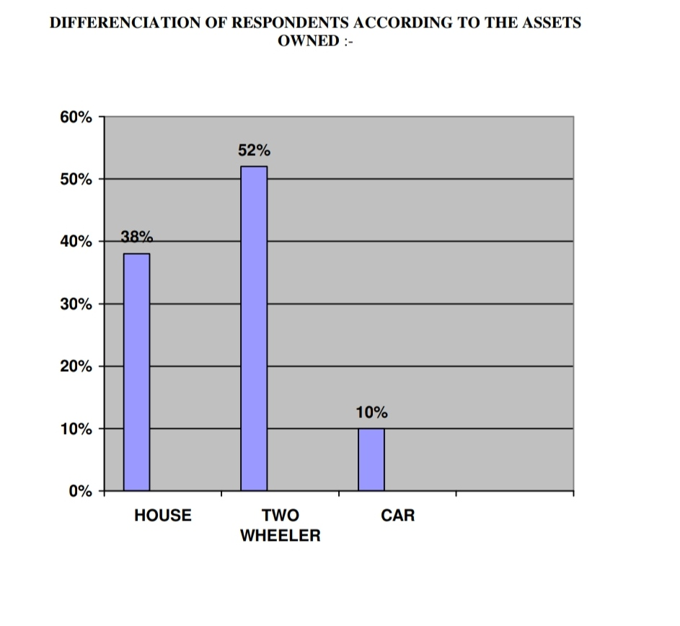

INFERENCE: This table helps us to know that most of consumers with life insurance policies own two wheelers with 52%, 19% of consumers own house and 5% of the consumers own car.

TABLE-7

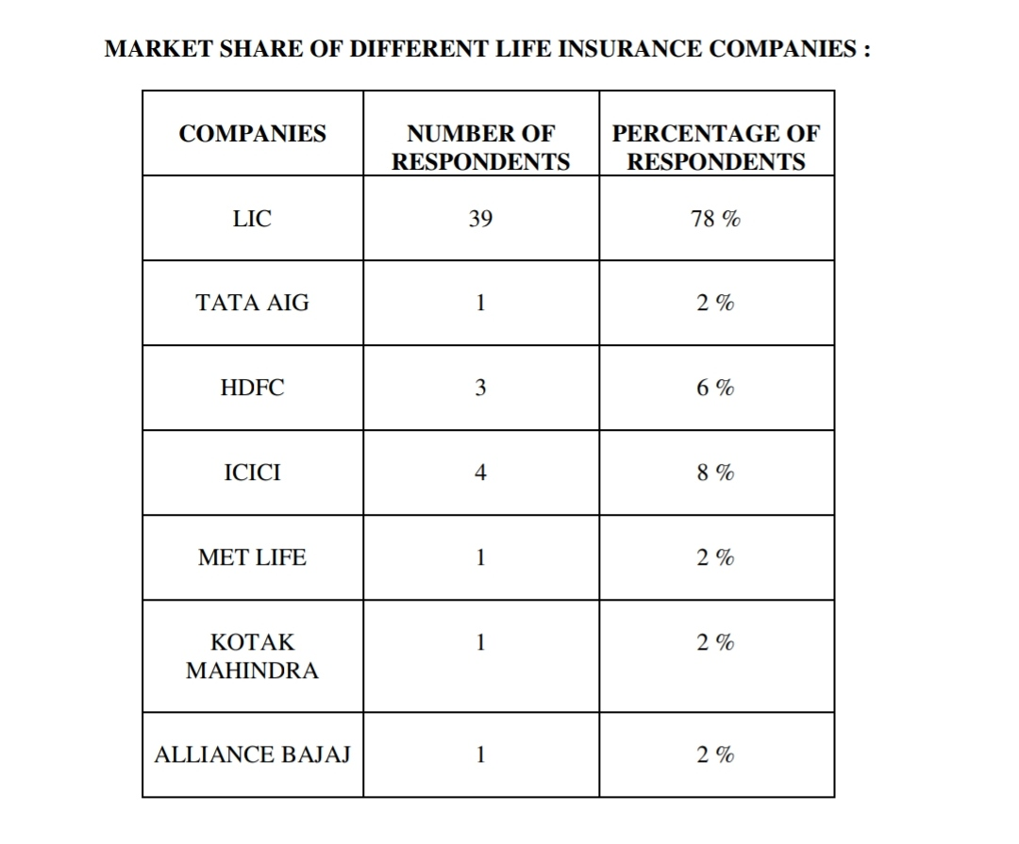

SOURCE:-SURVEY DATA

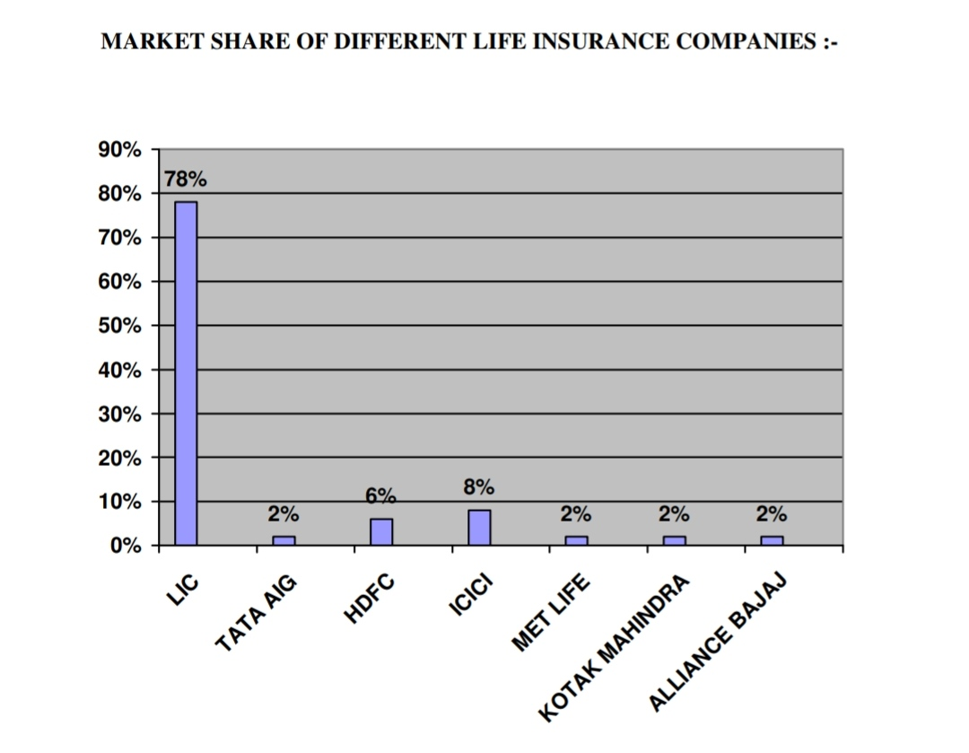

INFERENCE:

This table helps us to understand the market share of different life insurance companies. LIC has a major share of 78 %, followed by ICICI Prudential with 8% market share, followed by HDFC Standard Life with 6% market share.

TABLE 8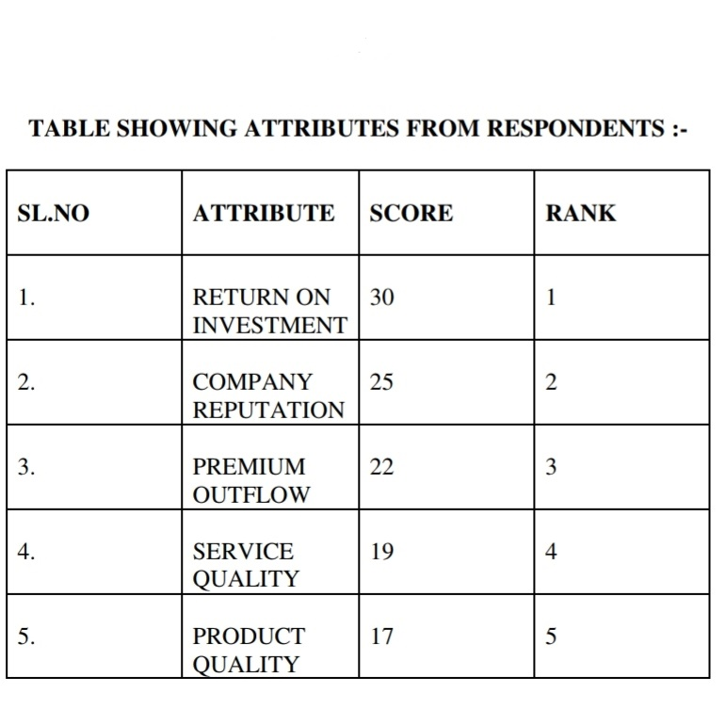

SOURCE:-SURVEY DATA

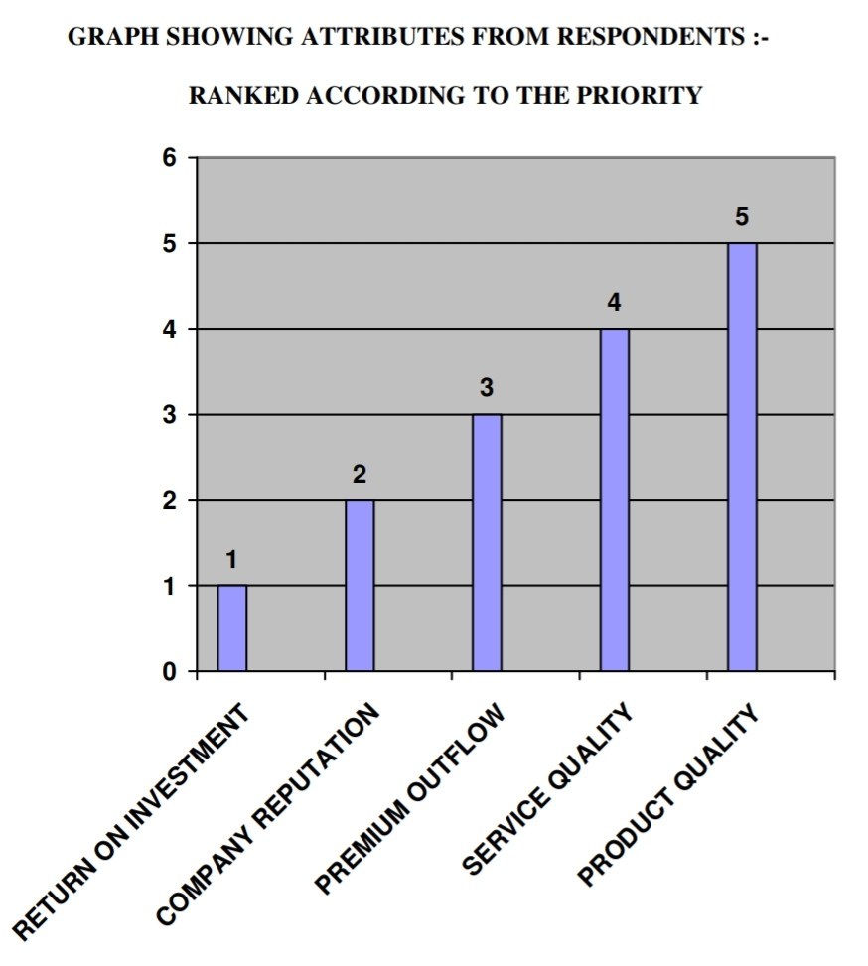

SOURCE:-SURVEY DATA

INTERPRETATION:

This table shows the strengths and weaknesses of the brand, and what are the important criteria or attributes on which decision making is done. From this table we can infer that consumers give more importance for Return on investment, secondly they prefer company reputation, and then premium outflow followed by service quality and product quality.

Score of different insurances company

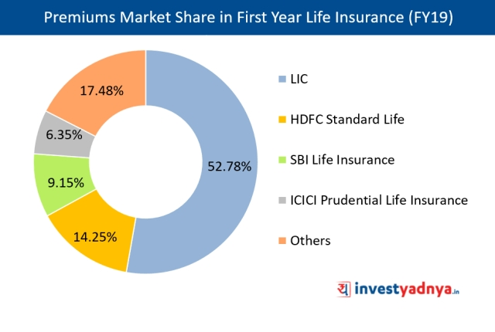

INTERPRETATION

From the above figure it can ranked the life insurance companies, LIC stands first, followed by ICICI Prudential followed by HDFC Standard life, followed by TATA AIG.

CHAPTER 4

SUGGESTIONS & CONCLUSION OF STUDY

5.1 SUMMARY OF FINDINGS

• The majority of respondents belong to the age group of 19 to 28 years with 56% followed by age group of 29 to 38 years with 18%.

• The male consumers capture the Market share with 74%, followed by the female consumers with 26%.

• The majority of the consumers of life insurance policies are private employees with

48% and Government employees with 40%

• The dominant income group having life insurance group belong to the group of 5001 to 10,000 followed by 10,001 to 15,000.

• LIC has a major market share of 78%.

• The factors which influenced to buy life insurance policy is the personal factor, followed by family, friends, agents and advertisements.

• The value of respondents life insurance policy costs more than 5, 00,000 followed by 1,00,000 to 5, 00,000.

• Majority of the people (52%) prefer to invest in bank others (48%) prefer to invest in insurance company.

• Majority of consumers are satisfied with the service and quality of products of their life insurance companies.

• Majority of consumers (78%) would like to communicate the service offered by life insurance companies.

• Majority of consumers (58%) are aware about less than 5 life insurance companies.

• LIC stands first followed by ICICI prudential, followed by HDFC Standard Life.

CONCLUSION

This study titled “Study of Consumers Perception about Life Insurance Policies” enables the Life Insurance Companies to understand how consumer’s perception differs from person to person. How a consumer selects, organizes and interprets the service quality and the product quality of different Life Insurance Policies, offered by various Life Insurance Companies

The response of the insurance companies has been very positive and within a short span on time, the Indian insurance market scenario has seen a perceptible change in terms of improved customer service benchmarks and introduction of innovative and tailors made products.

Most of the insurance majors have represented in the form of joint venture in Indian market.

The new products that have been introduced by the companies have certain innovative features in terms of better customer services and also wider covers. This has given customer ample choice to select products.

RECOMMENDATIONS AND SUGGESTIONS

With regard to insurance products, consumers respond at different rates, depending on the consumers characteristics. Hence Insurance companies should try to bring their new product to the attention of potential early adopters.

a) Due to the intense competition in the life insurance market, the life insurance companies have to adopt better strategies to attract more customers.

b) Keeping the cost, quality and return on investment in tact is necessary in order to tackle the competition.

c) Life insurance products are taken mainly by middle and higher income group.

Hence they should be regarded as maim targeted income groups. Life insurance products which are suitable for lower income group should also be released so that the market share increases.

d) Return on investment company reputation and premium outflow are most preferred attributes that are expected by the respondents. Hence greater focus should be given to these attributes.

e) Private life insurance companies should adopt effective promotional strategies to increase the awareness level among the consumers.

f) Life insurance companies should ask for their consumer feedback to know whether the consumers are really satisfied or dissatisfied with the service and product of the companies. If they are dissatisfied, then the reasons for dissatisfaction should be found out and should be corrected in future.

g) The LIC brand name has earned a lot of goodwill and enjoys high brand equity.

As there is intense competition in life insurance market, LIC should work hard to maintain its top position and offer better service and product.

QUESTIONNAIRE

Respected sir/ madam

I Gaurav student of BBA in Finance, pursuing a research project on “Consumer perception about life insurance policy measures in life insurance Corporation at Ghumarwin (HP).

I will grateful to you if your valuable time & efforts with your valuable views on the subject of this research study.

1. NAME..............................................
2. AGE...................................................
3. ADDRESS…………………………….
4. Phone number……………………….
5. Occupation……………………………

1. Do You Own

* House
* Two Wheeler
* Car

7. Do you have a Life Insurance Policy with any Life Insurance Company?

* Yes
* No

7a) If yes, name the Company___________________________________

b) Name the policy which you own_____________________________

8) What factors do you consider while buying a life insurance policy?

* Premium Outflow
* Company Reputation
* Service Quality
* Product Quality
* Return on Investment

9. What factors influenced to buy Life Insurance Policy?

* Personal interest
* Friends
* Family
* Agents
* Advertisements
* others

10. What is the value of your life insurance?

* >10,000
* 10,000-25,000
* 25,000-50,000
* 50,000-1,00,000
* >1,00,000

11. Do you prefer to invest your money in a Insurance company or in a Bank?

* Insurance Company
* Bank

12. Are you satisfied with your current Life Insurance Company?

* Yes
* No

If Yes Why?___________________________________________

If No Why?___________________________________________

13. How do you rate the service offered by your Life Insurance Company?

* Excellent
* Very Good
* Good
* Average
* Poor

14. Would you like to communicate the service offered by your Life Insurance Company to others?

* Yes
* No

15. How many Life insurance Companies do you know?

* <5
* 5-7
* 8-10

16. How do you rate the following Life Insurance Companies?

* LIC
* HDFC
* ING VYSYA
* MET LIFE INDIA INSURANCE
* BAJAJ ALLIANZ
* ICICI Prudential
* TATA AIG
* Others

17. Would you like to continue with the same Life Insurance Company?

* Yes
* No

***Thank you for your Time& experience***

BIBLIOGRAPHY

TEXT BOOKS:-

1) Services Marketing : Ravi Shankar.

2) Marketing Management : Philip Kotler.

3) Consumer Behaviour : Leon G

4) Principles of insurance Law : Dr. Avtar Singh.

WEBSITES:-

WWW.GOOGLE.COM

WWW.LIC.COM